Daniel Meyer

CSE 420

Fall 2018

Homework 1

**Part 1: (Success)**

#include <stdio.h>

#include <stdlib.h>

#include <math.h>

#include <iostream>

#include <GL/glut.h>

void init(void)

{

glClearColor(1.0, 1.0, 1.0, 0.0);

glMatrixMode(GL_PROJECTION);

gluOrtho2D(-5.0, 20.0, -5.0, 20.0);

glPointSize(3.0);

}

void setPixel(GLint x, GLint y)

{

glBegin(GL_POINTS);

glVertex2i(x, y);

glEnd();

}

void line()

{

int x0 = 0, y0 = 0, xn = 18, yn = 6, x, y; //(0,0) to (18,6)

int dx, dy, //deltas

pk, //decision parameter

k; //looping variable

glClear(GL_COLOR_BUFFER_BIT);

glColor3f(1, 0, 0);

setPixel(x0, y0); //plot first point

// difference between starting and ending points

dx = xn - x0;

dy = yn - y0;

pk = 2 * dy - dx;

x = x0; y = y0;

for (k = 0; k < dx - 1; ++k) {

if (pk < 0) {

pk = pk + 2 * dy; //calculate next pk

//next pixel: (x+1, y )

}

else {

//next pixel: (x+1, y+1)

pk = pk + 2 * dy - 2 * dx; //calculate next pk

++y;

}

++x;

setPixel(x, y);

}

glFlush();

}

void myInit()

{

glColor3f(0.0, 0.0, 1.0);

glLineWidth(3.0);

}

int main(int argc, char **argv) {

glutInit(&argc, argv);

glutInitDisplayMode(GLUT_SINGLE | GLUT_RGB);

glutInitWindowPosition(250, 250);

glutInitWindowSize(500, 500);

glutCreateWindow("Bresenham Line");

init();

glutDisplayFunc(line);

glutMainLoop();

return 0;

}

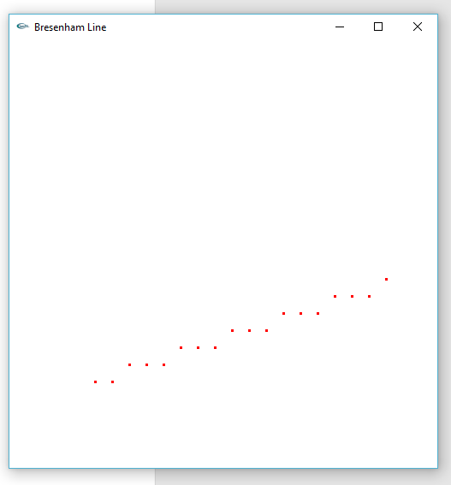

**1st 4 values of y:**

x0 = 0, y0 = 0, xn = 18, yn = 6

dx = 18 – 0 = 18, dy = 6 – 0 = 6

Initial point = (x0, y0) = (0, 0)

p0 = 2dy – dx = 12 – 18 = -6 -> p0 < 0 so (x+1, y) -> (1,0)

p1 = p0 + 2dy = -6 + 12 = 6

p1 = 6 -> p1 > 0 so (x+1, y+1) -> (2,1)

p2 = p1 + 2dy – 2dx = 6 + 12 – 36 = -18

p2 = -18 -> p2 < 0 so (x+1, y) -> (3,1)

p3 = p2 + 2dy = -18 + 12 = -6

p3 = -6 -> p3 < 0 so (x+1, y) -> (4,1)

p4 = p3 + 2dy = -6 + 12 = 6

……

**Part 2: (Success)**

#include <Windows.h>

#include <iostream>

#include <math.h>

#include <GL/GL.h>

#include <GL/GLU.h>

#include <GL/GLUT.h>

const float pi = 3.14159265358979;

const float e = 2.7818;

void setWindow(GLdouble left, GLdouble right, GLdouble bottom, GLdouble top)

{

glMatrixMode(GL_PROJECTION);

glLoadIdentity();

gluOrtho2D(left, right, bottom, top);

}

void setViewport(GLint left, GLint right, GLint bottom, GLint top)

{

glViewport(left, bottom, right - left, top - bottom);

}

void myDisplay(void)

{

glClear(GL_COLOR_BUFFER_BIT);

glMatrixMode(GL_MODELVIEW);

glLoadIdentity();

//glBegin(GL_LINE_STRIP);

glBegin(GL_POINTS);

for (float x = -4.0; x < 4.0; x += 0.01)

{

glVertex2f(x, (pow(e, -abs(x)) * sin(2 * pi * x)));

}

glEnd();

glFlush();

}

void myInit(void)

{

glClearColor(1.0, 1.0, 1.0, 0.0);

glColor3f(0.0f, 0.0f, 1.0f);

glLineWidth(2.0);

glPointSize(2.0);

}

void main(int argc, char** argv)

{

glutInit(&argc, argv);

glutInitDisplayMode(GLUT_SINGLE | GLUT_RGB);

glutInitWindowSize(640, 480);

glutInitWindowPosition(100, 150);

glutCreateWindow("HW1 Graph");

glutDisplayFunc(myDisplay);

myInit();

setWindow(-4.5, 4.5, -1.0, 1.0);

setViewport(0, 640, 0, 480);

glutMainLoop();

}

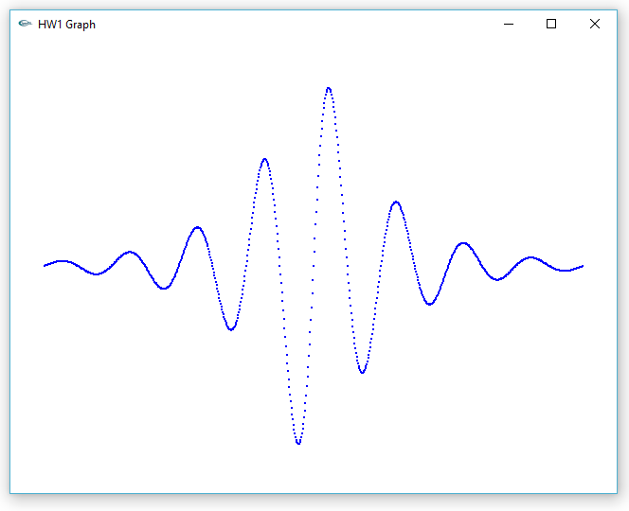

**Part 3: (Success)**

#include <Windows.h>

#include <iostream>

#include <math.h>

#include <GL/GL.h>

#include <GL/GLU.h>

#include <GL/GLUT.h>

class GLintPoint

{

public:

GLint x, y;

};

class Point2

{

public:

float x, y;

void set(float dx, float dy) { x = dx; y = dy; }

void set(Point2 &p) { x = p.x; y = p.y; }

Point2(float xx, float yy) { x = xx; y = yy; }

Point2() { x = y = 0; }

};

Point2 currPos;

Point2 CP;

const float pi = 3.14159265358979;

void moveTo(Point2 p)

{

CP.set(p);

}

void moveTo(float x, float y)

{

CP.set(x, y);

}

void lineTo(Point2 p)

{

glBegin(GL_LINES);

glVertex2f(CP.x, CP.y);

glVertex2f(p.x, p.y);

glEnd();

glFlush();

CP.set(p);

}

void lineTo(float x, float y)

{

glBegin(GL_LINES);

glVertex2f(CP.x, CP.y);

glVertex2f(x, y);

glEnd();

glFlush();

CP.set(x, y);

}

void myInit(void)

{

glClear(GL_COLOR_BUFFER_BIT);

glClearColor(1.0, 1.0, 1.0, 0.0);

glColor3f(0.0, 0.0, 1.0);

}

void setWindow(float left, float right, float bottom, float top)

{

glMatrixMode(GL_PROJECTION);

glLoadIdentity();

gluOrtho2D((GLdouble)left, (GLdouble)right, (GLdouble)bottom, (GLdouble)top);

}

void setViewport(int left, int right, int bottom, int top)

{

glViewport(left, bottom, right - left, top - bottom);

}

//draw an n-sided regular polygon

void draw_polygon(int N, float cx, float cy, float radius, float rotAngle)

{

if (N < 3) return; //bad number of sides

double angle = rotAngle * pi / 180; //initial angle

double theta = 2 * pi / N; //angle increment

moveTo(radius * cos(angle) + cx, radius * sin(angle) + cy);

for (int k = 0; k < N; k++) //repeat n times

{

angle += theta;

lineTo(radius * cos(angle) + cx, radius * sin(angle) + cy);

}

} //draw_polygon

void rosette(int N, float radius)

{

Point2 *pointlist = new Point2[N];

GLfloat theta = (2.0f * pi) / N;

for (int c = 0; c < N; c++)

{

pointlist[c].set(radius * sin(theta * c), radius * cos(theta * c));

}

for (int i = 0; i < N; i++)

{

for (int j = 0; j < N; j++)

{

moveTo(pointlist[i]);

lineTo(pointlist[j]);

}

}

}

void draw_circle(float cx, float cy, float radius)

{

glColor3f(1.0, 0.0, 0.0);

const int numVerts = 100;

draw_polygon(numVerts, cx, cy, radius, 0);

glPointSize(3);

glFlush();

}

void draw_arc(float cx, float cy, float radius, float sAngle, float sweep)

{

glColor3f(0.0, 1.0, 0.0);

const int n = 30;

float angle = sAngle * pi / 180;

float theta = sweep * pi / (180 * n);

moveTo(cx + radius * cos(angle), cy + radius * sin(angle));

for (int i = 1; i < n; i++)

{

lineTo(cx + radius * cos(angle), cy + radius * sin(angle));

angle += theta;

}

}

void draw_star(float cx, float cy, float radius, float rotAngle)

{

float angle = rotAngle;

moveTo(cx + radius * cos(angle), cy + radius * sin(angle));

for (int i = 0; i <= 5; ++i)

{

lineTo(cx + radius * cos(0.017453393 * angle), cy + radius * sin(0.017453393 * angle));

angle += 144;

}

}

void render()

{

glClear(GL_COLOR_BUFFER_BIT);

setWindow(-12.0, 12.0, -12.0, 12.0);

setViewport(0, 500, 0, 500);

draw_star(8.0, -2.0, 3.0, 55.0);

draw_polygon(5, 7.0, 5.0, 3.0, 18.0);

rosette(25, 5.0);

glFlush();

}

void main(int argc, char** argv)

{

glutInit(&argc, argv);

glutInitDisplayMode(GLUT_SINGLE | GLUT_RGB);

glMatrixMode(GL_PROJECTION);

glLoadIdentity();

glutInitWindowSize(640, 480);

glutCreateWindow("Turtle");

glutDisplayFunc(render);

myInit();

glutMainLoop();

}

